Ex. No 4: Analyze email headers and detect email spoofing using MHA (Mail Header Analyzer) Description:
Here's a step-by-step guide on how to execute and analyze an email header:

Access the Email Header
  - Gmail: Open the email, click the three dots (More) in the upper right corner, and select "Show original."
  - Outlook: Open the email, click on "File," then "Properties," and find the "Internet headers" box.
  - Yahoo: Open the email, click on the three dots (More), and select "View raw message."

Copy the Email Header
  - Once you access the header, copy all the text that appears. This text contains various metadata fields about the email's journey from the sender to your inbox.
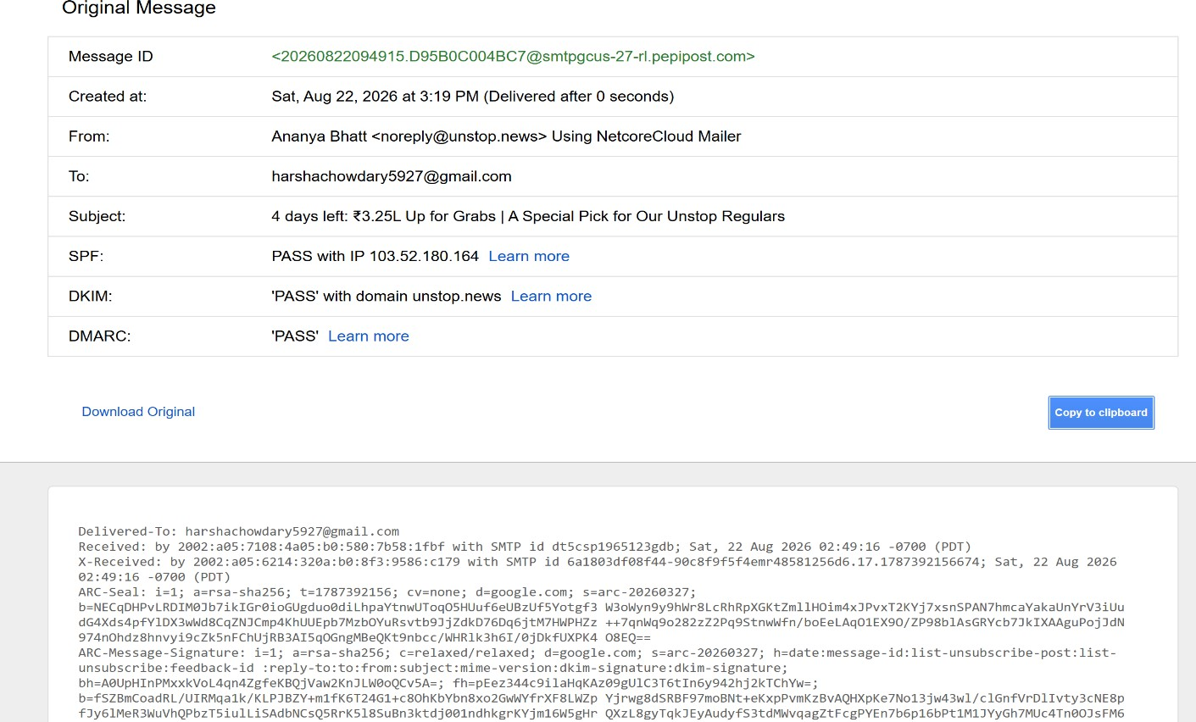

Identify Key Header Fields
  - From: The sender’s email address.
  - To: The recipient's email address.
  - Date: The date and time the email was sent.
  - Subject: The email's subject line.
  - Return-Path: The return address if the email bounces.
  - Received: A list of servers the email passed through on its way to the recipient. This is usually the most critical part of header analysis.

  - Message-ID: A unique identifier for the email.
  - SPF (Sender Policy Framework) / DKIM (DomainKeys Identified Mail): Indicators of email authentication.

Analyze the ‘Received’ Fields
  - The Received fields show the path the email took from the sender to the recipient. These fields are listed in reverse order (from the last server to the first).
  - Each Received line will show:
    - The sending server's hostname/IP address.
    - The receiving server's hostname/IP address.
    - The date and time the email passed through.
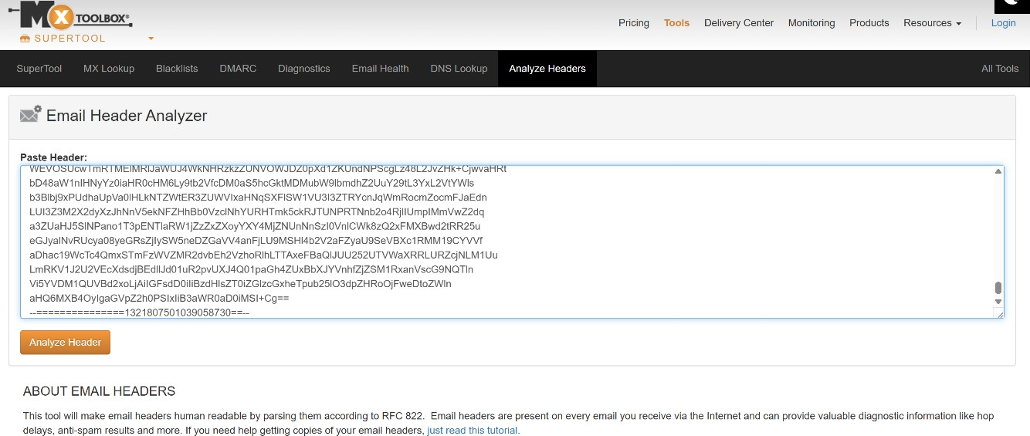

Check for IP Addresses and Hostnames
  - Use tools like WHOIS or online IP lookup services to identify the geographical location and ownership of the IP addresses found in the Received lines.
  - Check if any IP addresses are suspicious or if the hostname does not match the expected sending server.
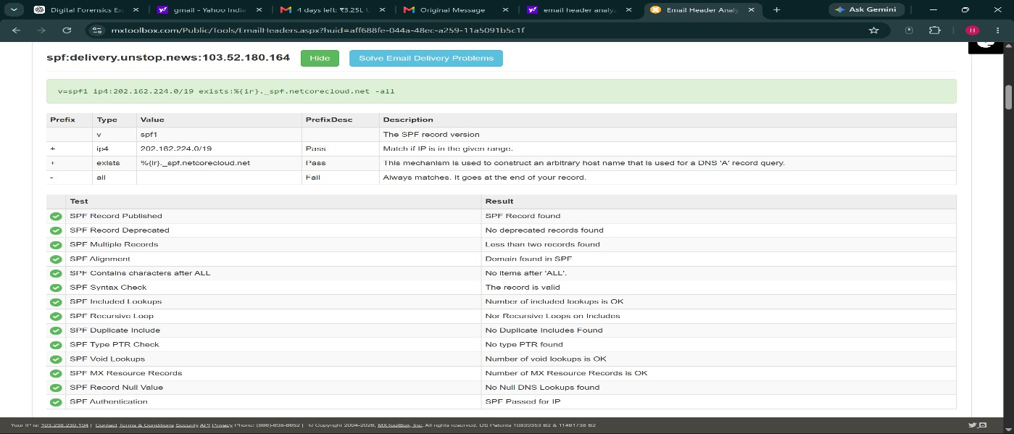

Examine the SPF, DKIM, and DMARC Results
  - SPF: Checks if the sender's IP is authorized to send emails for the domain.
    - Pass: Indicates the IP is authorized.
    - Fail: The IP is not authorized and could be a sign of spoofing.
  - DKIM: Verifies that the email content has not been altered in transit.
    - Pass: The email has not been tampered with.
    - Fail: The email content may have been altered.
  - DMARC: A policy that uses SPF and DKIM to authenticate the email.
    - Pass: Indicates alignment with SPF/DKIM policies.
    - Fail: Indicates possible spoofing or tampering.
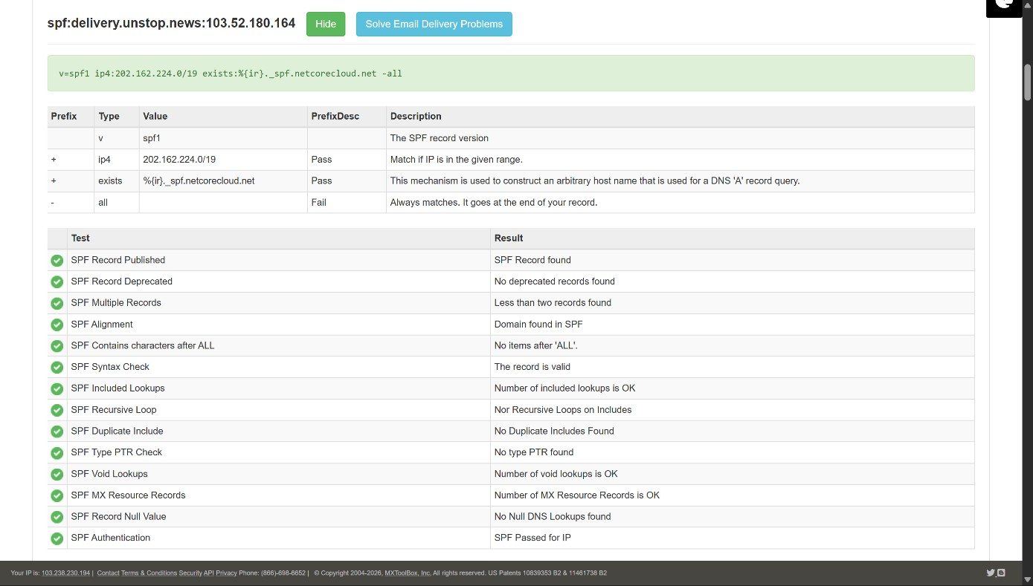
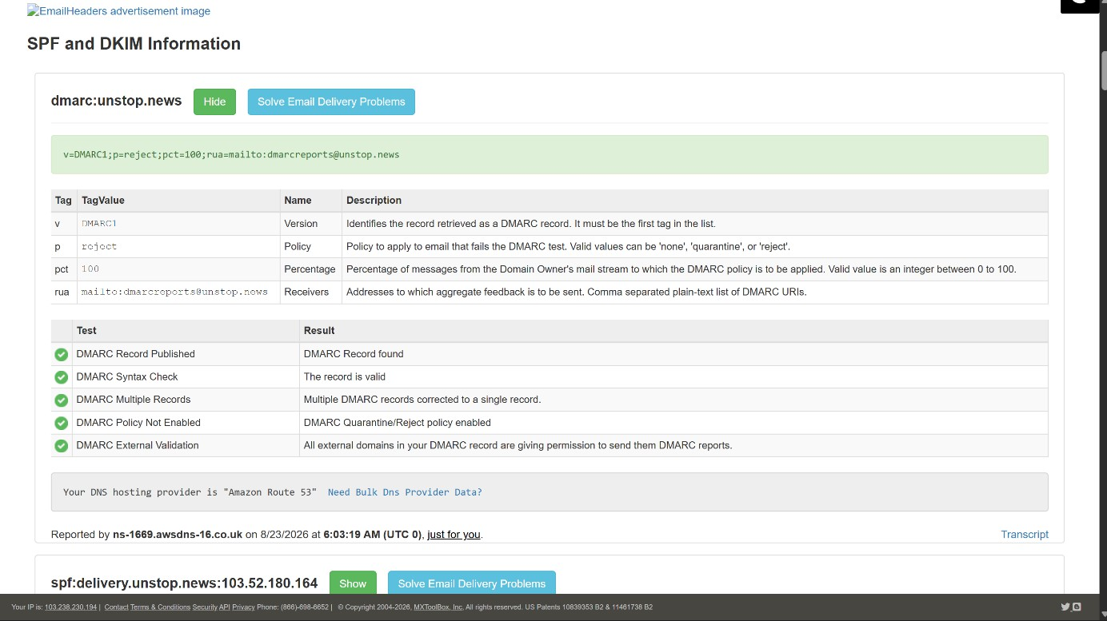

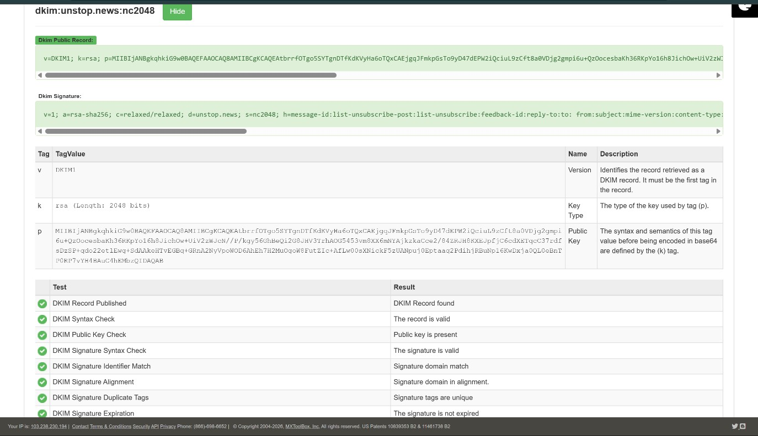

Analyze the ‘Message-ID’
  - The Message-ID is unique to each email. It usually includes the domain of the sending server.
  - Check if the domain in the Message-ID matches the sender's domain. If not, it could be a sign of spoofing.

Look for Anomalies
  - Mismatch in Email Domains: Check if the From domain matches the domains in Return-Path, Message-ID, and other authentication results.
  - Strange IP Addresses: Be wary of IP addresses that do not match the known sending server or are from unexpected locations.
  - Suspicious Time Stamps: Check for significant time discrepancies in the Received lines, which could indicate delays or rerouting.

Use Online Tools
  - Use online email header analysis tools like MXToolbox or Google's G Suite Toolbox to automatically parse and analyze the email header.

Document and Report Findings
  - Document all your findings, especially if you detect phishing or spoofing.
  - Report suspicious emails to your IT department or email provider for further investigation.

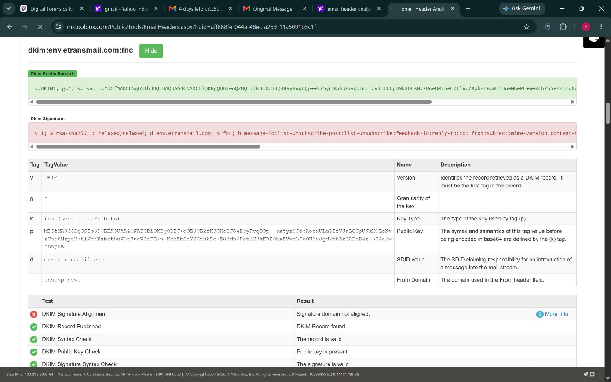

Example of a Header Analysis
Here’s a quick example with a sample header:
vbnet Copy code
Received: from mail.example.com (mail.example.com [192.0.2.1])
by mail.receiver.com with ESMTP id u29si8604336pjs.40.2023.08.10.07.00.16; Thu, 10 Aug 2023 07:00:16 -0700 (PDT)
Received: by mail.example.com with SMTP id a1mr1243772ywh.51; Thu, 10 Aug 2023 07:00:15 -0700 (PDT)
Message-ID: <CA+7eu=4pSeXgQ@mail.example.com>
  - Check IP Addresses: Lookup 192.0.2.1 and ensure it is associated with mail.example.com.
  - Verify SPF/DKIM: Check if mail.example.com is authorized to send emails for this domain.
  - Compare Time Stamps: Ensure the times make sense chronologically without unusual delays.

Rubrics

Criteria & Marks Assigned | Mark Allotted | Mark Awarded
1. GitHub Activity & Submission Regularity | 3
2. Application of Forensic Tools & Practical Execution | 3
3. Documentation & Reporting | 2
4. Engagement, Problem-Solving & Team Collaboration | 2
Total | 10

